2200030216 WEEK-4 spring-rest-handson

REST - Country Web Service

RUN THE ABOVE SPRING APPLICATION

mvn spring-boot:run

see on which server you are working on

here:-8083

the required outputs are seen on this link in the browser or postman

<http://localhost:8083/country>

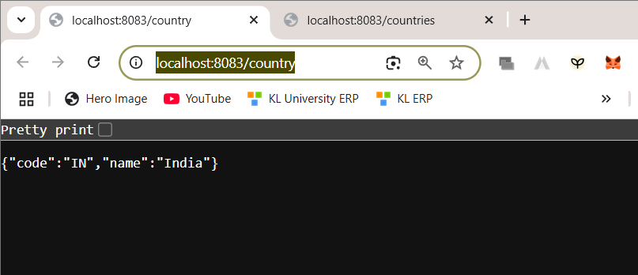

<http://localhost:8083/countries>

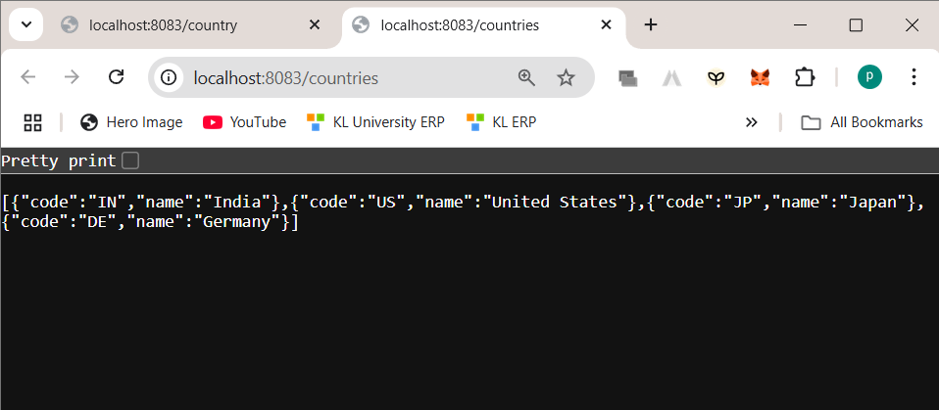

CONTROLLER METHOD

package com.cognizant.spring_learn.controller;

import java.util.List;

import org.springframework.beans.factory.annotation.*Autowired*;

import org.springframework.context.ApplicationContext;

import org.springframework.web.bind.annotation.*GetMapping*;

import org.springframework.web.bind.annotation.*RequestMapping*;

import org.springframework.web.bind.annotation.*RestController*;

import com.cognizant.spring_learn.model.Country;

@*RestController*

@*RequestMapping*

public class CountryController {

    @*Autowired*

    private ApplicationContext context;

    @*RequestMapping*("/country")

    public Country getCountryIndia() {

        return context.getBean("IN", Country.class);

    }

    @*GetMapping*("/countries")

    public List<Country> getAllCountries() {

        return context.getBean("countryList", List.class);

    }

}

Country(code="IN", name="India")

{

"code": "IN",

"name": "India"

}